Hands All Around Quilt Guild ● Programs’ Workshops 2018 – 2019
Please review the complete Workshop Guidelines on the Guild website.
Check the Guild website for further details on supply lists, locations, and links to speaker websites.

PLEASE MAKE CHECKS PAYABLE TO HAAQG and DATE AS REQUESTED BELOW.
A SEPARATE CHECK IS REQUIRED FOR EACH CLASS; YOU CAN ADD ANY KIT FEES TO THAT CLASS’ CHECK.

Either hand this in with payment at a guild meeting or mail with your check to:
Carole Fay ● 2305 Rainbow Ave ● Bloomington, IL 61704

NAME PHONE EMAIL
PLEASE PRINT LEGIBLY PLEASE PRINT LEGIBLY

Circle the date in the first column to register for events. ● Indicate your check number in the last column.
Date | Workshop  Sample | Workshop | Member Fee | Non-Member Fee | Add: Kit Cost | Check #
09/07/18  Jill Finley | 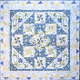 | Carousel | $35 | $45 | Both classes have prework. Get $12 pattern locally or jillilystudio.com. Kits available online. | Please date check 07/01/18
09/08/18  Jill Finley |  | Cabin Fever | $35 | $45 |  | Please date check 07/01/18
10/05/18  Paula Nadelstern | 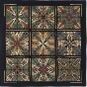 | Sixty Thirty:  A Kaleidoscope Class | $35 | $45 | Both classes need 2 yds of Paula’s fabric @ $12/yd.  See supply list – she will bring fabric & supplies for purchase. | Please date check 08/01/18
10/06/18  Paula Nadelstern | 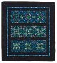 | Simple Symmetry | $35 | $45 |  | Please date check 08/01/18
11/02/18  Angela Walters | 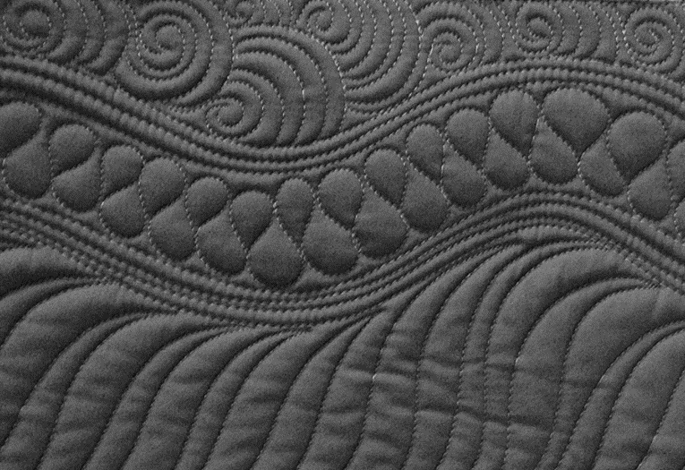 | Quilting Negative Space | $35 | $45 | No kits or patterns.  There is prework for both classes – check supply list for details. | Please date check 09/01/18
11/03/18  Angela Walters | 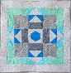 | Dot to Dot Quilting | $35 | $45 |  | Please date check 09/01/18
12/07/18  Bill Kerr | 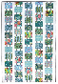 | Working with  Large Scale Prints | $35 | $45 | No charge for patterns for either class.  Check supply list. | Please date check 10/01/18
12/08/18  Bill Kerr | 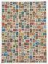 | Rediscovering  Your Stash | $35 | $45 |  | Please date check 10/01/18
02/08/19  Mark Sherman |  | Remarkable  Stained Glass | $35 | $45 | Mandatory fabric kit $40  Pay at registration | Please date check 12/01/18
02/09/19  Mark Sherman | 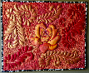 | Machine Trapunto for the Timid Quilter | $35 | $45 | Mandatory fabric kit $45  Pay at registration | Please date check 12/01/18
03/08/19  Edyta Sitar | 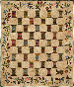 | Strip Exchange:  Spool Quilt | $35 | $45 | Mandatory fabric kit $45  Pay at registration | Please date check 01/01/19
03/09/19  Edyta Sitar |  | Triangle Exchange:  Tree Farm | $35 | $45 | Mandatory fabric kit $45  Pay at registration | Please date check 01/01/19
04/05/19  Mary Lou Weidman | 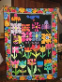 | Flower Power | $35 | $45 | No extra charge for  handouts given in class | Please date check 02/01/19
04/06/19  Mary Lou Weidman |  | Creative Cow | $35 | $45 | $12 pattern  Pay at registration | Please date check 02/01/19

